Global Sourcing Solution

Solution Design

# Revision History

|  |  |  |  |
| --- | --- | --- | --- |
| **Date** | **Version** | **Author** | **Description/Comments** |
| 9/15/14 | 0.1 | Gopal Gogineni | Initial Draft |
| 11/5/14 | 0.11 | Richard Uranga | Updated 2.1 with Admin and User Preferences |
| 11/5/14 | 0.14 | Gopal Gogineni | Updated context diagram referenced in section 1.4 |
| 11/5/14 | 0.15 | Richard Uranga | Updated with new ADD provided by architect section 2.4 |
| 1/14/15 | .20 | Gopal Gogineni | Added dev server information to Section 9 |
| 1/23/15 |  | Gopal Gogineni | Sprint 2 modifications |

Table of Contents

Revision History 2

1. Introduction 4

2. System Design 6

3. Information Architecture and Data Model 9

4. Integration 11

5. User Interface 12

6. Security 13

7. Disaster Recovery (DR) 16

8. Non-Functional Requirements (NFR) 19

9. Infrastructure Architecture 22

10. Configuration Management 28

11. Component Designs 29

# Introduction

## Application Summary

|  |  |  |
| --- | --- | --- |
| **Application Name:**  **Global Sourcing Solution** | **Primary Business Area/Dept:**  **GM / Global Sourcing** | **Business Owner:**  **Bill Anderson & Natalie Cover** |
| **I.S. LOB:**  **IS Drug/GM** | **Application Usage:**  **Multiple Departments, Enterprise, Vendors** | **Technology Skills Required:**  **Java, Spring, angular.js, RDBMS** |

## Solution Purpose and Scope

**Solution Drivers/Goal:**

To develop a new global sourcing application to replace our current vendor developed global sourcing application that meets or exceeds current capabilities.

**Solution Scope and Objectives:**

* Goal (1): Develop a new global sourcing application to replace our vendor developed application
  + Objectives: To provide the business a newly developed application that is equal in functionality and higher in quality than our current global application.
* (Future) Goal (2): Enhance base functionality to include the commitment to buy process
  + Objectives: To provide the business with the ability to commit to purchase items without having to wait for a PO to be developed. This will allow the business to act quickly and purchase items in a more efficient manner.
* (Future) Goal (3): Enhance base functionality to include the offline design and offline quote
  + Objectives: To provide the business the ability to work offline when traveling and working in areas where the internet is unavailable.

**High-level Functionality:**

All global sourcing processes are within scope of this project. This includes:

* Goals & Objectives
* Sourcing RequestsQuotes (Future)
* QA (Future)
* Reports (Future)
* Commitment To Buy (Future)

## Definitions, Acronyms, and Abbreviations

|  |  |
| --- | --- |
| **Term/Acronym** | **Definition** |
| GSS | An acronym of the name of the application being developed (Global Sourcing Solution) |
| Global Sourcing | The team responsible for assisting buyers in sourcing products from abroad. |
| Sourcing Manager | A member of the Global Sourcing team. Will have administrative rights within the application. |
| BDM | Business Development Manager (buyer) |
| BDA | Business Development Assistant. A person with this role is usually assigned to one or more BDMs. |
| Merchandising Manager | A 3rd party sourcing agency manager |
| Merchandiser | A 3rd party sourcing agent |
| OVD | Oracle Virtual Directory |

## Project Related Information

All project related information can be found on the [**GSS Sharepoint**](http://isteams.corp.heb.com/sites/ISGMTeam/GSS/default.aspx):

* [**Project Charter document**](http://isteams.corp.heb.com/sites/ISGMTeam/GSS/Project%20Management/Project%20Charter%20GSS.docx)
* [**Project Context Diagram document**](http://isteams.corp.heb.com/sites/ISGMTeam/GSS/Project%20Management/GSS%20-%20Project%20Context%20Diagram.vsd)
* [**Project Requirements**](http://isteams.corp.heb.com/sites/ISGMTeam/GSS/Functional%20Documents/Sprint%20II%20Approved%20By%20Business.pdf)

# System Design

## Key Business Features and Processes

|  |  |
| --- | --- |
| **Feature/Process** | **Description** |
| Goals & Objectives creation | Allows a buyer (or sourcing manager on behalf of a buyer) to create a proposed product design to submit to vendors. |
| Timelines | Provides sourcing managers the ability to communicate deadlines in the global sourcing process to buyers. |
| Announcements | Provides sourcing managers a one way communication method to users of the GSS application. |
| User Settings | Provides all users with the ability to manage their preferences and profile. |
| Administration | Provides sourcing managers (Admin) the ability to do the following:   * Create and edit season / events * Create and edit color groups * Manage the association of a buyer to one or more BDAs * Create announcements |
| Sourcing Requests | Provides Sourcing / Merchandising users the ability to view Objectives and to choose which suppliers to request Quotes from. |
| Alerts | Provides users the ability to be notified of pending work. |
| Add Users (Vendors) | Provide the ability to add 3rd party users to the application. |
| Sourcing Requests | Provide the ability for Merchandisers to send the Goals and Objectives to potential suppliers. |

## Key Technical Features

|  |  |
| --- | --- |
| **Feature/Process** | **Description** |
|  |  |
|  |  |
|  |  |

## Key Architecture Points

|  |  |
| --- | --- |
| **Decision** | **Rationale** |
| GSS will be a JAF 4.5 based application | JAF 4.5 is the latest version of the JAF and will allow for the greatest ease of development. |
| GSS will use Tomcat7 and JDK7 for the service tier | Tomcat7 and JDK7 are the current HEB standards. |
| GSS will use Spring Profiles | Spring Profiles allows simplified environment and code management. |
| GSS will use Gradle for builds | Gradle is the current HEB standard build tool |
| GSS will use the angular.js UI framework | Angular.js is capable of providing the responsiveness desired by our business users. |
| GSS will use Apache httpd | Apache httpd will be used to serve static content and provide a layer of abstraction to our service tier |
| GSS will use Git for source control | Git is the current HEB standard SCM. |
| GSS will use an Oracle Exadata database | A database is needed to store application data. Oracle is used regularly at HEB and has a good knowledge base. Using Exadata will give the application security flexibility going forward. |
| GSS will use Centera for content storage | Centera was chosen to allow for less application server configuration and better scalability when compared to a NAS solution. |
| GSS will use ClamAV for virus scanning | ClamAV is the HEB standard for virus scanning on file upload. |

## Application Diagram

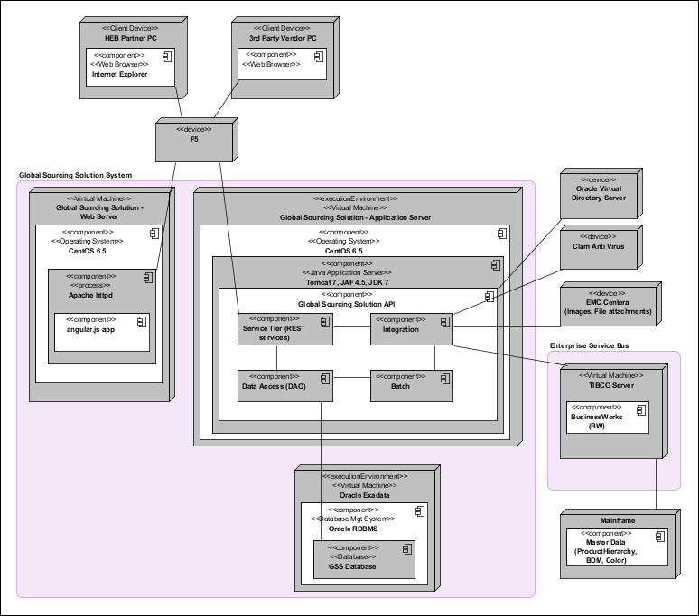

## System Component Summary

|  |  |
| --- | --- |
| **Component** | **Description** |
| F5 | Standard load balancer. Will proxy requests starting with /gss_api/* to the application server and all others to the web server. |
| HEB Partner PC | Desktop computer that partners (Buyers,Sourcing Managers, etc.) will use to access the GSS application. IE9 is the current HEB standard browser. |
| Vendor PC | Desktop computer that 3rd party vendors (Merchandisers, Suppliers, etc) will use to access the GSS application. IE9+ and current versions of Chrome and Safari will be supported. |
| Web Server | Apache httpd web server which hosts an Angular.js based html web application which is dependent on the Application Server for authentication and data services. |
| Application Server | Tomcat7 Java web application. Consists of a REST service tier and several batch jobs that will access the application database and integrations. |
| Database | Oracle RDBMS used to store application data. |
| Oracle Virtual Directory | Used to authenticate users using LDAPS protocol. |
| Clam Anti Virus | Used to scan file uploads for viruses before accepting. |
| EMC Centera | Used to store files. |
| TIBCO Enterprise Service Bus | Runs web services used by the application. |
| Mainframe | Hosts Master Data database and is accessed by ESB. |
| UI Component | Software component containing angular.js UI code, which will be deployed to the Web Server. Will execute on the client browser and interact heavily with the API component. |
| API Component | Software component containing Java code, which will be deployed to the Application Server. Will be responsible for access of application data and allowing the UI component to interact with all other system. |

# Information Architecture and Data Model

## Database Model

The latest database model can be found at the link below.

<http://isteams.corp.heb.com/sites/DataServices/InfoMgmt/Shared%20Documents/Data%20Models/GSS%20-%20Global%20Sourcing%20System.pdf>

## Data Layouts

|  |  |  |
| --- | --- | --- |
| **Name** | **Data Type** | **Description and Link to Detail** |
| Objectives List Export | Excel file | <http://isteams.corp.heb.com/sites/ISGMTeam/GSS/Functional%20Documents/Export_Template_Objectives.xlsx> |
| Timelines List Export | Excel file | <http://isteams.corp.heb.com/sites/ISGMTeam/GSS/Functional%20Documents/Export_Template_Timelines.xlsx> |
|  |  |  |

## Data Management

|  |  |
| --- | --- |
| **GSS Database** | |
| **Data Type** | Oracle 11g |
| **Backup** | Database is backed up daily |
| **Data Retention** | TBD in future sprints |
| **Archiving** | TBD in future sprints |
| **Purging** | TBD in future sprints |

# Integration

## Data Integration and Context Diagram

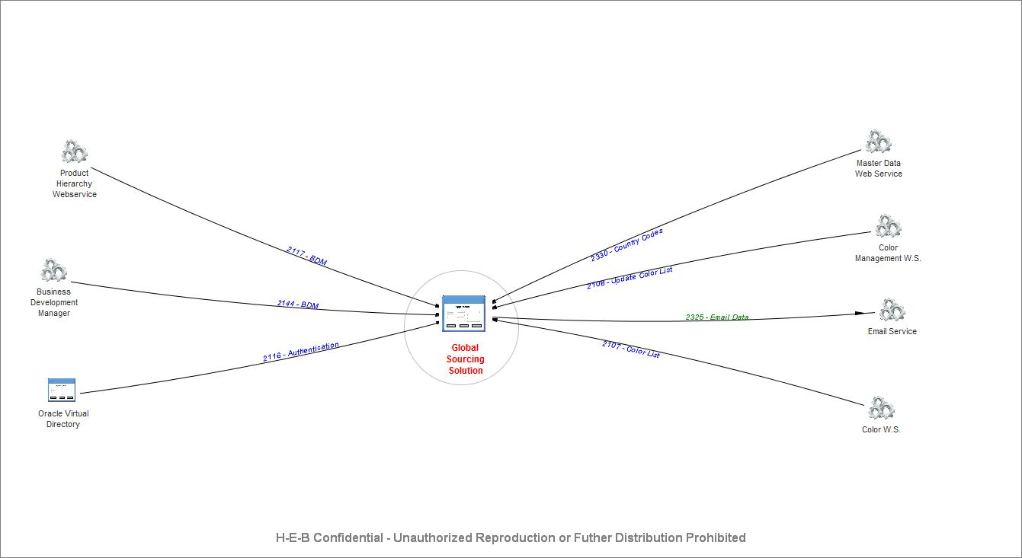

Figure 1 - Data Integration and Context Diagram

## Integration and Data Mapping Specifications

|  |  |  |  |  |  |
| --- | --- | --- | --- | --- | --- |
| **ID** | **Interface** | **Source System** | **Target System** | **Integration Service Type** | **Status** |
| 2107 | Color List | Color W.S. | Global Sourcing Solution | Webservice | Exists |
| 2108 | Update Color List | Color Management W.S. | Global Sourcing Solution | Webservice | Exists |
| 2116 | Authentication | Oracle Virtual Directory | Global Sourcing Solution | Java Adapter Framework (JAF) | Exists |
| 2117 | BDM | Product Hierarchy Webservice | Global Sourcing Solution | Webservice | Exists |
| 2144 | BDM | Business Development Manager | Global Sourcing Solution | Webservice | Exists |
| 2325 | Email Data | Global Sourcing Solution | Email Service | Webservice | Exists |
| 2330 | Country Codes | Master Data Web Service | Global Sourcing Solution | Webservice | Exists |

# User Interface

## UI Requirements and Constraints

|  |  |
| --- | --- |
| **Application/Component** | **Requirement or Constraint** |
| Goals and Objectives screen | Buyers/BDAs should only be able to view/edit Objectives related to commodities they support. |
| Sourcing Request screen | Merchandisers should only be able to view/respond to Sourcing Requests that were sent to the Sourcing Office they support. HEB Sourcing Managers will have access to all Sourcing Requests. |
|  |  |

## Screens

[iRise Simulation](http://drpapw0018601.corp.heb.com/iRise/player/render?dummy=0.03321862020788113&_target_key_=a9dfd6bfa3104cd5b7486a329163cdb8&windowReference=__window__0&inDocumentView=SIMULATION&_project_key_=d1d50a8fb0a7463083797d96c06f38fa&studioSimulation=true)

<http://isteams.corp.heb.com/sites/ISGMTeam/GSS/Functional%20Documents/Sprint%20II%20Screenshots.docx>

|  |  |  |
| --- | --- | --- |
| **Name** | **Description and Link to Detail** | **Used By** |
| Login Page | Used for authentication | Buyer / Sourcing Manager |
| Landing Page | First page seen after logging in. Gives user the ability to navigate the application. | Buyer / Sourcing Manager |
| Objectives (Single) | Used to create/modify/view a single Objective. | Buyer / Sourcing Manager |
| Objectives (Multiple) | Used to create several Objectives at once. | Buyer / Sourcing Manager |
| Announcements (View) | Used to view announcement history | Buyer |
| Timelines | Used to view timelines | Buyer / Sourcing Manager |
| User Preferences | Used to set preferences on how to view timelines on the landing page | Buyer / Sourcing Manager |
| Season/Events | Used to create new buying seasons / events | Sourcing Manager |
| Buyer/BDA Relationships | Used to associate BDAs to buyers. Needed for access control to Objectives. | Sourcing Manager |
| Color Groups | Used to create groups of related colors. | Sourcing Manager |
| Announcements (Create) | Used to create announcements to users of the application. | Sourcing Manager |
|  |  |  |

## Reports

N/A

|  |  |
| --- | --- |
| **Name** | **Description and Link to Detail** |
|  |  |
|  |  |
|  |  |

# Security

## Authentication

The Global Sourcing Application will only be accessible to HEB partners and 3rd party Vendors.

|  |  |
| --- | --- |
| **Application/Component** | **Authentication Method** |
| GSS UI (angular.js) | Login page will make a REST service call to the GSS API component to authenticate and start a session. Subsequent calls will send the returned JSESSIONID as an authentication token. All communication will be over https. |
| GSS API (services) | The initial authentication service call will start an HTTP Session and return a JSESSIONID. The authentication service will authenticate using 2 methods:   * If the user is a partner, the credentials will be validated with OVD (via LDAPS) * If a vendor, the credentials will be validated against the password stored on the GSS database   + Passwords must be at least 8 characters and include an uppercase character, lowercase character, and number   + Passwords are encoded using a salted SHA-256 hash function   + Passwords will need to be changed every 60 days   + When resetting passwords, the previous 4 passwords cannot be used   + Accounts will be disabled after 90 days of inactivity   + Login attempts will be logged   Subsequent calls will include the JSESSIONID and confirm the HTTP session is still active. This is very similar to the way non-angular Java Web Applications function today. |

## User Management and Maintenance

BDMs are added as users of the system through an integration that will find all GM Buyers and add them to the GSS.USERS table. Other users (partners and vendors) will be added through administrative screens in the GSS application.

Partners will only have their Onepass ID and Role added to the GSS System.

Vendors will go through a process of generating a unique ID, assigning a temporary password, and emailing the password to them for initial login. Those users will reset the password to a value of their choosing and answer 3 personal security questions on initial login.

|  |  |  |
| --- | --- | --- |
| **Approving Department/Location** | **Primary Approver** | **Secondary Approvers** |
| GM / Global Sourcing | Natalie Cover | Sherri Koppold, Karissa Ybarra, Tuan Le |
| 3rd party Merchandisers | Merchandising Manager | Merchandisers |

## Authorization

|  |  |  |  |  |
| --- | --- | --- | --- | --- |
| **User or Group** | ***Buyer*** | ***Admin*** | ***Sourcing Office*** | ***3rd party Administration*** |
| BDM | X |  |  |  |
| ABDM | X |  |  |  |
| BDA | X |  |  |  |
| Sourcing Manager | X | X | X | X |
| Merchandiser |  |  | X |  |
| Merchndising Manager |  |  | X | X |

BDAs can modify Objectives for BDMs they report to. Sourcing Managers can modify Objects for any BDM.

|  |  |  |  |  |  |
| --- | --- | --- | --- | --- | --- |
| **Role** | ***Create/Modify Objectives*** | ***Create/Modify Sourcing Requests*** | ***Administration Functions*** | ***Add Merchandisers*** | ***Add Vendors*** |
| Buyer | X | X |  |  |  |
| Admin | X | X | X | X | X |
| Sourcing Office |  | X |  |  | X |
| 3rd Party Administration |  |  |  | X | X |

## Confidentiality and Privacy

All data is transferred via https to ensure confidentiality. User session is automatically closed after a 30 minute inactivity window.

No sensitive data is output to application logs.

There is no personal, cost, or retail information being handled by the application.

|  |  |  |
| --- | --- | --- |
| **Identify the type of data requiring protection** | **Category (PII, PCI, EPHI, Cost/Retail, or Other)** | **Measures taken to protect the confidentiality of this type of data** |
| 3rd party vendor password |  | Stored on encrypted Exadata database in HSM. Field is encoded using a salted SHA-256 hash function. |
| 3rd party vendor password recovery questions |  | Stored on encrypted Exadata database in HSM. Fields are encoded using a salted SHA-256 hash function. |
| Supplier Information Tax ID | PII | Stored on encrypted Exadata database in HSM. Field is encoded using a salted SHA-256 hash function. |
| Supplier Information Bank Account / Routing Number |  | Stored on encrypted Exadata database in HSM. Field is encoded using a salted SHA-256 hash function. |

## Data Integrity

All editable data fields will include client and server side validation appropriate to their data type/nature. Client side validation will be in JavaScript to ensure all required fields are filled out and that inputs are within limits as described in the requirements document. Server side validation will be performed via JSR-303 annotation based validations. All data exchanged between client and server is encrypted and sent through SSL.

## Logging and Auditing

Every data update stores in the database the id of the user who applied the change and the time at which it took place. Hibernate Envers will be utilized to keep an audit history of updates. Audit tables will not be purged for at least 1 year after the Objective is complete.

## Network

Application will be available to external users over the internet. External access is achieved through an external F5 and Apache HTTPD server hosted on the DMZ. The application server proper will be hosted behind the corporate firewall. Only the HTTPS port will be open between the apache web server and the application server.

## Digital Certificates

TBD

|  |  |  |  |
| --- | --- | --- | --- |
| **Server** | **Certificate Issuer** | **Issued To:** | **Valid From-To:** |
|  |  |  |  |
|  |  |  |  |
|  |  |  |  |
|  |  |  |  |

## Other

## Attachment management

All offer attachments submitted by vendors will be scanned for viruses via ClamAV servers before being stored on the file repository. Attachments will be limited to a few file types (doc, docx, xls, xlsx, jpg, gif, ppt, pdf, txt) . Attachments will be stored in Centera with the reference key (content URI) being stored in the GSS database to be able to retrieve the files at a later time.

# Disaster Recovery (DR)

## DR Category

## DR Tier

Global Sourcing Solution is a Tier 2 application, with an RTO of 48 hours.

## DR Recovery Time Objective

|  |  |  |
| --- | --- | --- |
| **Component**  **(Application or Database name)** | **Recovery Time** | **Comments** |
| Global Sourcing Solution | 48 hours | Drug/GM Team |
| TIBCO Integrations | 4 hours | ICC Team |
| GSS Database | 4 hours | Operations |
| OVD | 4 hours | Operations |
|  |  |  |

## DR Recovery Point Objective

|  |  |  |  |
| --- | --- | --- | --- |
| **Data Component**  **(SID, Filesystem name, etc.)** | **Type of Data**  **(Oracle DB, SQL Server DB, Filesystem, etc.)** | **Data Loss**  **(in minutes or hours)** | **Comments** |
| Database | Oracle DB | 1 day |  |
| EMC Centera | Files | 1 day |  |
|  |  |  |  |
|  |  |  |  |

## DR Strategy

The disaster recovery strategy for the Global Sourcing Solution application will be Active-Active and will employ an F5 to send requests to the live data center if one data center goes down.

### **Architectural Patterns**

|  |  |  |  |  |  |
| --- | --- | --- | --- | --- | --- |
| **Component** | **Type (Physical/Virtual)** | **Host Name** | **IP Address** | **Data Center** | **Architectural Pattern** |
| Global Sourcing Solution Web Server | Virtual | TBD | TBD | Arsenal / W200 | Active/Active |
| Global Sourcing Solution Application Server | Virtual | TBD | TBD | Arsenal / W200 | Active/Active |
|  |  |  |  |  |  |

### **DR Technologies**

|  |  |
| --- | --- |
| **Technology** | **Purpose** |
| F5 Load Balancer | Balances the load between application servers, allowing Active/Active configuration |
| Oracle Dataguard | To meet RPO |
| EMC Centera Replication | To meet RPO |

## DR Dependencies

## Infrastructure Appliances

|  |  |  |  |  |
| --- | --- | --- | --- | --- |
| **IP Address** | **Port** | **DC Location** | **Module/Network** | **Primary/Secondary** |
| TBD | 80/443 | Arsenal / WHSE 200 | F5 Load balancer | Arsenal/W200 |
|  |  | Ars/W200 | EMC Centera - Core | Arsenal/W200 |
|  |  |  |  |  |

## Infrastructure Applications

|  |  |
| --- | --- |
| **Infrastructure Application** | **Dependency** |
| Vendor Oracle Virtual Directory Server | Needed to authenticate users in application |
| TIBCO webservices | Needed to display current item data |
| Oracle Database | Needed for data storage |
| EMC Centera | Needed to store/retrieve offer attachments |

## Business Applications

|  |  |
| --- | --- |
| **Business Application** | **Dependency** |
| NA |  |
|  |  |

## Recovery Procedures

Recovery Procedures can be found on the Information Solutions Disaster Recovery site at the link below.

<http://isteams.corp.heb.com/sites/DR/Recovery%20Documents/Recovery%20Procedures/GlobalSourcingSolution_RecoveryProcedures_v1.0.docx>

# Non-Functional Requirements (NFR)

## Service Level Agreements

|  |  |  |
| --- | --- | --- |
| **Measurement** | **Definition** | **Performance Target** |
| Service Availability Percent | The percent of time that the application is available minus the impact time from any events (scheduled maintenance for HEB and/or supporting services etc) | 99.99% |
| Problem Response | The time required for a user to receive a response after reporting a problem to the Help Desk | 1-High Priority-30 minutes 2-Medium Priority – 2 hours 3-Low Priority – 24 hours |
| Problem Circumvention or Resolution Time | The time required for a user to receive a circumvention or a solution after reporting a problem to the Help Desk | 1-High Priority - 120 minutes 2-Medium Priority - 24 hours 3-Low Priority - 72 hours |
| Problem Response (during Maintenance Window) | The time required for a user to receive a response after reporting a problem to the Help Desk during Maintenance | 1-High Priority-30 minutes 2-Medium Priority – 2 hours 3-Low Priority – 24 hours |
| Problem Circumvention or Resolution Time(during Maintenance Window) | The time required for a user to receive a circumvention or a solution after reporting a problem to the Help Desk during Maintenance | 1-High Priority - 2 hours 2-Medium Priority - 24 hours 3-Low Priority- 72 hours |

|  |  |  |  |  |  |  |  |  |
| --- | --- | --- | --- | --- | --- | --- | --- | --- |
| **Times** | **Sunday** | **Monday** | **Tuesday** | **Wednesday** | **Thursday** | | **Friday** | **Saturday** |
| Standard Business Use | N/A | 8:00 – 17:00 | 8:00 – 17:00 | 8:00 – 17:00 | | 8:00 – 17:00 | 8:00 – 17:00 | N/A |
| Peak Hours | N/A | 9:00 – 16:00 | 9:00 – 16:00 | 9:00 – 16:00 | | 9:00 – 16:00 | 9:00 – 16:00 | N/A |
| Maintenance Window | 16:00 – 18:00 | 16:00 – 18:00 | 16:00 – 18:00 | 16:00 – 18:00 | | 16:00 – 18:00 | 16:00 – 18:00 | 16:00 – 18:00 |

## Capacity and Scaling

|  |  |  |  |
| --- | --- | --- | --- |
| **User Group** | **Internal**  **External** | **Total Number**  **Of Users** | **Expected Concurrent Users** |
| Buyer | Internal | 50 | 15 |
| Sourcing Manager | Internal | 5 | 3 |
| Merchandiser / Merchandising Manager | External | 20 | 5 |
| Vendor | External | 1000 | 0 |

|  |  |  |
| --- | --- | --- |
| **Application/Component** | **Unit of Work Type** | **Capacity Requirements/Unit of Measure** |
| Objective Creation | Save a newly created Objective | 1 Objective / 10 minute |
| Objective View | View a previously created Objective | 1 Objective / 10 seconds |
| Objective List | View a listing of accessible Objectives | 1 search / 10 seconds |
| Sourcing Request Creation | Submit an objective to a vendor for quote | 5 Sourcing Requests / 10 minutes |

## Performance Planning

|  |  |  |
| --- | --- | --- |
| **Application/Component** | **Unit of Work Type** | **Performance Requirements** |
| Objective Creation | Data Storage | Under 3 seconds response time |
| Objective View | Data Retrieval | Under 2 seconds response time |
| Objective List | Data Retrieval | Under 2 seconds response time |
| Sourcing Request Creation | Data Storage | Under 1 second response time |
| Sourcing Request View | Data Retrieval | Under 2 seconds response time |

## Monitoring

|  |  |  |
| --- | --- | --- |
| **Application/Component** | **Monitoring Tool** | **Monitoring Metrics** |
| Web Application | SiteScope monitoring | Ping  CPU  URL Response time |
| Global Sourcing Solution Database Server | SiteScope | Monitor database service is up and running |
| TIBCO Business Works | SiteScope | TIBCO will leverage current monitoring solution to communicate issues with completing integrations. |

## Testability

|  |  |  |
| --- | --- | --- |
| **Application/Component** | **Testing Tool** | **Test System Description** |
| Service Component | JUnit | Java Classes can be tested via JUnit |
|  |  |  |
|  |  |  |

## Supportability

TBD

# Infrastructure Architecture

## Infrastructure Diagrams

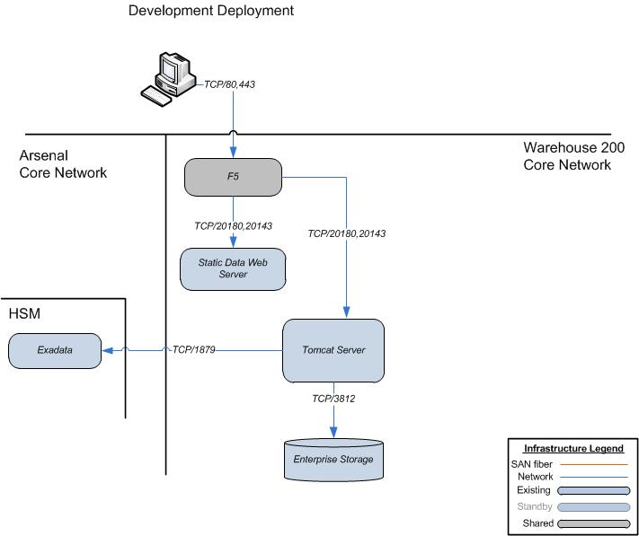

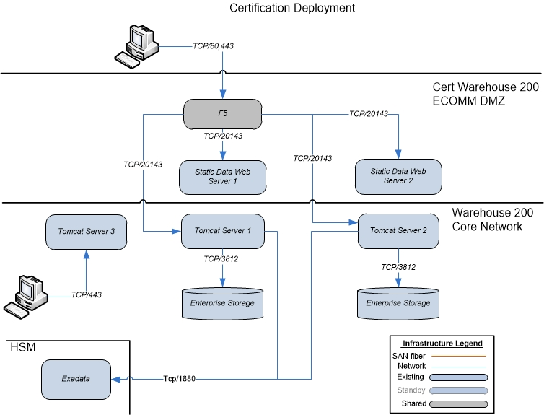

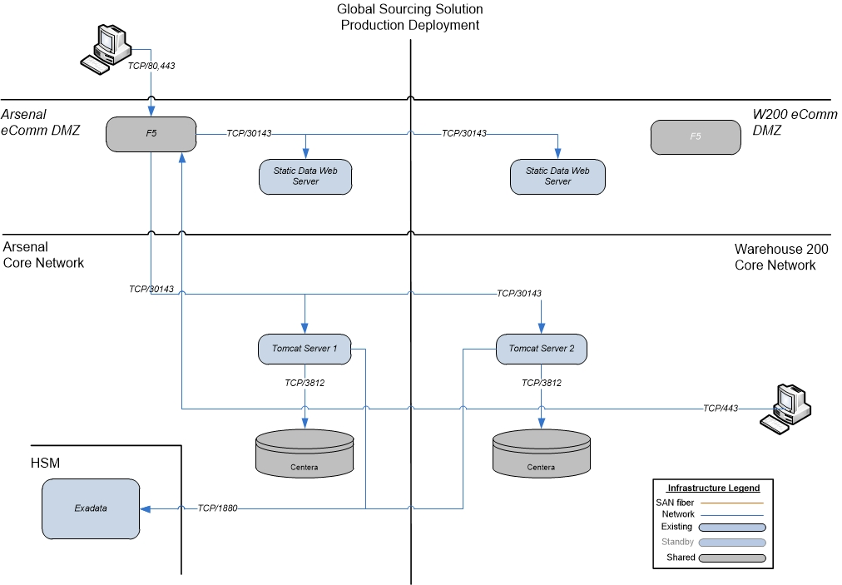

## Infrastructure Architecture Notes

## Server Information

Table 9. : Server Information

|  |  |  |  |  |  |  |  |  |  |
| --- | --- | --- | --- | --- | --- | --- | --- | --- | --- |
| **Reference** | **IP Address** | **Hostname** | **Amount of RAM** | **Number of CPU's** | **Type of Server** | **Operating System** | **Location** | **Server Model** | **Service Tag** |
| *1* | *172.28.187.20* | *w2dwbl0052102* | 2 | 1 | VM (Web) | CentOS 6.5 | W2 | N/A | N/A |
| *2* | *172.28.55.127* | *w2dapl0052102* | 4 | 2 | VM (Tomcat) | CentOS 6.5 | W2 | N/A | N/A |
| 1 | 172.28.187.21 | w2cwbl0052101 | 2 | 1 | VM (Web) | CentOS 6.6 | W2 | N/A | N/A |
| 2 | 172.28.187.22 | w2cwbl0052102 | 2 | 1 | VM (Web) | CentOS 6.6 | W2 | N/A | N/A |
| 3 | 172.28.55.230 | w2capl0052101 | 4 | 2 | VM (Tomcat) | CentOS 6.6 | W2 | N/A | N/A |
| 4 | 172.28.55.240 | w2capl0052102 | 4 | 2 | VM (Tomcat) | CentOS 6.6 | W2 | N/A | N/A |
| 1 | 172.16.85.48 | arpwbl0052101 | 2 | 1 | VM (Web) | CentOS 6.6 | AR | N/A | N/A |
| 2 | 172.16.85.49 | w2pwbl0052101 | 2 | 1 | VM (Web) | CentOS 6.6 | W2 | N/A | N/A |
| 3 | 172.17.64.198 | arpwbl0052101 | 4 | 2 | VM (Tomcat) | CentOS 6.6 | AR | N/A | N/A |
| 4 | 172.27.71.179 | w2papl0052101 | 4 | 2 | VM (Tomcat) | CentOS 6.6 | W2 | N/A | N/A |
|  |  |  |  |  |  |  |  |  |  |

## Storage Information

Table 9. : Storage Information

|  |  |  |  |
| --- | --- | --- | --- |
| **Hostname** | **Storage Array** | **Storage Type** | **VPLEX (Y/N)** |
| **centera_dev.heb.com** | Centera |  |  |
| **centera_dev2.heb.com** | Centera |  |  |
| **centera_dev.heb.com** | Centera |  |  |
| **centera_dev2.heb.com** | Centera |  |  |
| Primary (arsenal)  Ars_centera1.heb.com  Ars_centera2.heb.com  Failover(w200)  W200_centera1.heb.com  W200_centera2.heb.com | Centera |  |  |

## f5 Information

Table 9. : f5 Information

|  |  |  |  |  |  |  |  |  |  |  |
| --- | --- | --- | --- | --- | --- | --- | --- | --- | --- | --- |
| f5 Appliance: | Core Network F5 – gss-dev.heb.com  eComm Cert f5 – gss-cert.heb.com  eComm Prod f5 – gss.heb.com | | | | | | |  |  |  |
| Virtual IP Address: | 172.28.175.130 (gss-dev.heb.com)  172.28.175.150 (gss-cert.heb.com)  172.x.x.x (gss.heb.com) | | | | | | |  |  |  |
|  |  |  |  |  |  |  |  |  |  |  |
| Monitor Information |  |  |  |  |  |  |  |  |  |  |
| **Name** | **Type** | **Interval** | **Timeout** | **Send String** | **Receive String** | **Alias Address** | **Alias Service Port** |  |  |  |
| TBD |  |  |  |  |  |  |  |  |  |  |
|  |  |  |  |  |  |  |  |  |  |  |
|  |  |  |  |  |  |  |  |  |  |  |
| Node Information |  |  |  |  |  |  |  |  |  |  |
| **Name** | **IP Address** | **Health Monitor** | **Ratio** | **Connection Limit** |  |  |  |  |  |  |
| TBD |  |  |  |  |  |  |  |  |  |  |
|  |  |  |  |  |  |  |  |  |  |  |
|  |  |  |  |  |  |  |  |  |  |  |
| SNAT Information |  |  |  |  |  |  |  |  |  |  |
| **Name** | **IP Address** | **Health Monitor** | **Ratio** | **Connection Limit** |  |  |  |  |  |  |
| Auto Map |  |  |  |  |  |  |  |  |  |  |
|  |  |  |  |  |  |  |  |  |  |  |
| Pool Information |  |  |  |  |  |  |  |  |  |  |
| **Name** | **Translation** | **Origin** | **VLAN Traffic** |  |  |  |  |  |  |  |
| TBD |  |  |  |  |  |  |  |  |  |  |
|  |  |  |  |  |  |  |  |  |  |  |
| Virtual Server Information |  |  |  |  |  |  |  |  |  |  |
| **Name** | **Service Port** | **Type** | **Protocol** | **Protocol Profile (Client)** | **VLAN Traffic** | **SNAT Pool** | **Port Translation** | **Default Pool** | **Default Persistance Profile** | **Failback Persistance Profile** |
| TBD |  |  |  |  |  |  |  |  |  |  |

## Firewall Rule Information

Table 9. : Firewall Information

|  |  |  |  |  |  |  |  |
| --- | --- | --- | --- | --- | --- | --- | --- |
| Traffic Information | |  |  |  |  |  |  |
| **Index** | **Source Address** | **Source Port / Protocol** | **Destination Address** | **Destination Port / Protocol** | **Action Deny/Accept** | **Add/Remove Rule** | **Reason for Changes** |
| a | TBD |  |  |  |  |  |  |
| b |  |  |  |  |  |  |  |
| c |  |  |  |  |  |  |  |
| d |  |  |  |  |  |  |  |
| e |  |  |  |  |  |  |  |
|  |  |  |  |  |  |  |  |
| Network Address Translation | |  |  |  |  |  |  |
| **Index** | **Internal IP Address** | **Column5** | **Column1** | **External IP Address** | **Column2** | **Column3** | **Column4** |
| a | TBD |  |  |  |  |  |  |
| b |  |  |  |  |  |  |  |
|  |  |  |  |  |  |  |  |
| Firewall Module | |  |  |  |  |  |  |
| **Index** | **Firewall Name** |  | **Column1** | **DMZ IP Subnet** | **Column2** | **Column4** | **Column3** |
| a |  | TBD |  |  |  |  |  |
| b |  |  |  |  |  |  |  |

## Appliance Information

Table 9. : Appliance Information

|  |  |  |  |  |  |
| --- | --- | --- | --- | --- | --- |
| **Hostname** | **IP Address** | **Manufacturer** | **Location** | **Model** | **Serial Number** |
| N/A |  |  |  |  |  |
|  |  |  |  |  |  |

# Configuration Management

## Source Code

The project source code will be maintained using Git under the Drug-GM group. The project is available at the below URLs.

<https://git.heb.com/drug-gm/global-sourcing-solution>

<https://git.heb.com/drug-gm/global-sourcing-solution-ui>

**Source Code Project Directory**

The Services Component follows the standard Gradle project directory structure

* src/main/java – contains java classes.
* src/main/resources – contains resources files.
* src/test/java – contains test java classes.
* src/ws/java – Java classes generated from importing WSDL documents

The UI Component will contain the angular.js static content

* /webroot/ – contains the web application view jsp’s, javascript and css when applicable

### **Build Automation**

The Global Sourcing Solution application will use Jenkins and Gradle to build and deploy to Tomcat application servers and Apache web servers following standard processes.

### **Deployment Process**

The Global Sourcing Solution application will use Jenkins and Gradle to build and deploy to Tomcat application servers and Apache web servers following standard processes.

### **Patching**

Application patching will be achieved by following the standard build and deploy process mentioned above. Server patching will occur on an as needed basis by the SMO team with participation from the application team.

### **Other**

N/A

# Component Designs

### **UI Component**

### **Component Responsibility**

This component will provide users the means to interact with the Global Sourcing Solution application data. It will be written in angular.js and will make REST calls to the Services Component.

* Allow user to login to the application
* Allow user to view screens as allowed by his/her role
* Allow user to create Objectives as allowed by his/her role

### **Dependencies**

|  |  |
| --- | --- |
| **External Call To** | **Description** |
| GSS API Component | Dependent on the GSS API Component for all data and functionality. |
|  |  |
|  |  |

### **Code Structure**

Web application files, under /webroot/

|  |  |  |
| --- | --- | --- |
| **Package Name** | **Class Name** | **Description** |
| app |  | Core angular.js files |
| vendor |  | 3rd party javascript libraries |
| views |  | Javascript / HTML view files divided by screen functionality |

### **API Component**

### **Component Responsibility**

This component will be responsible for fulfilling all requests from the UI component and provide an interface for interacting with the following external systems and datastores.

* Oracle Virtual Directory (OVD)
* Global Sourcing Solution Database
* TIBCO WebServices for data retrieval
* EMC Centera file storage
* Clam AV antivirus service

This component will also be responsible for running batch processes at scheduled times using quartz. Spring profiles will be used to ensure that batch executions only occur on one server at any given time.

### **Methods/Subroutines/Functions**

|  |  |  |
| --- | --- | --- |
| **Method** | **Class** | **Description** |
| getObjective | ObjectiveService | Service used to retrieve an existing Objective |
| getBuyersForCurrentUser | UserService | Service used to retrieve supported BDMs for a BDA |
| getCommodyListByBDMCode | ProductHierarchyService | Service used to retrieve Commodities supported by selected Buyer |
| findAllEventsForBDM | EventService | Service used to retrieve Events related to Commodity selected |
| getAllProductBrands | ProductHierarchyService | Service used to retrieve GM Brands |
| searchPreferredVendor | VendorService | Service used to search for Suppliers by name |
| saveObjective | ObjectiveService | Service used to persist Objectives |
| getColorListFromWS* | ColorService | Service used to search for Colors |
| saveColor | ColorService | Service used to save a new color entered by User |
| retrieveFile | FileService | Service used to retrieve file from Centera |
| findAllEvents | EventService | Service used to retrieve all events |
| getEvent | EventService | Service used to retrieve event details |
| saveEvent | EventService | Service used to persist Events |
| getAnnouncements | AnnouncementService | Service used to retrieve announcement |
| saveAnnouncements | AnnouncementService | Service used to persist Announcements |
| getChildUsersForBuyer | UserService | Service used to retrieve BDAs for a buyer |
| getName | LdapLookupService | Service used to retrieve a name for a user ID |
| saveBuyerRelationships | UserService | Service used to persist Buyer Relationships |
| getColorGroups | ColorGroupService | Service used to retrieve existing Color Groups |
| saveColorGroup | ColorGroupService | Service used to persist Color Groups |
| getUserPreferences | UserPreferencesService | Service used to retrieve User Preferences |
| saveUserPreferences | UserPreferencesService | Service used to persist User Preferences |
| findObjectives | ObjectiveService | Service used to retrieve a list of Objectives that meets search criteria |
|  |  |  |

### **Dependencies**

|  |  |
| --- | --- |
| **External Call To** | **Description** |
| TIBCO Web Services | Required for communication with master data DB |
| OVD | Required for user authentication |
| Centera | Required for file stores and retrieval |
| ClamAV | Required for virus scanning files |
|  |  |

### **Process Flows and Sequences**

TBD

### **Code Structure**

Java classes under src/main/java

|  |  |
| --- | --- |
| **Package Name** | **Description** |
| com.heb.gss.batch | Classes related to batch functionality |
| com.heb.gss.config | Classes related to Spring Application configuration |
| com.heb.gss.controller | RestControllers accessible to UI Component |
| com.heb.gss.dto | Data transfer javabeans used for JSON mapping between UI and API code |
| com.heb.gss.integration | Classes which handle external integration points |
| com.heb.gss.mapper | Classes which handle mapping from DTOs to JPA entities and vice versa. |
| com.heb.gss.persistence | Classes which utilize the JPA provider for database access |
| com.heb.gss.security | Classes related to security |
| com.heb.gss.service | Services called by RestControllers. Contains business logic and persistence/integration calls |

Resources under src/main/resources

|  |  |  |
| --- | --- | --- |
| **Package Name** | **Class Name** | **Description** |
|  |  | Spring configuration files |
|  |  |  |